DEPARTMENT OF COMPUTER SCIENCE AND ENGINEERING
CSA1611 – Data Warehousing and Data Mining
SMART SUSTAINABLE CITY ENERGY INTELLIGENCE PLATFORM (SSEIP)
An Integrated Data Warehousing and Data Mining Solution for the Chennai Energy and Sustainability Authority (CESA), incorporating Smart Campus EV Charging Management
Common Team Assignment Report
Bloom's Taxonomy Level: BTL 6 – Create
SDG Mapping: SDG 7 – Affordable and Clean Energy | SDG 11 – Sustainable Cities and Communities | SDG 12 – Responsible Consumption and Production

Field | Details
Team Number | [To be filled by team]
Team Members (Name / Reg. No.) | V.Vijay - 192525264
Course code | CSA 1611 DWDM
Faculty | Ammalan Ghosh
Date of Submission | 03/09/2026
GitHub Repository Link

Table of Contents

1. Problem Statement and Problem Formulation
2. Objectives and Expected Outcomes
3. Requirements, Constraints and Assumptions
4. Application of Relevant Course Knowledge / Concepts
5. Proposed Solution and Methodology
6. Data Warehouse Architecture and Dimensional Model
7. Sample Dataset Description
8. Data Preprocessing
9. Classification and Prediction
10. Clustering
11. Association Rule Mining
12. Implementation Environment and Tools
13. Test Cases and Results
14. Results and Validation
15. Analysis, Comparison, Trade-offs and Justification
16. Broader Considerations / SDG Relevance
17. Conclusion, Limitations and Possible Improvements
18. Individual Contribution of Group Members
19. References
20. One-Page Individual Reflection

1. Problem Statement and Problem Formulation

A rapidly growing metropolitan city is facing rising electricity demand, escalating energy costs, excessive resource consumption, and growing volumes of municipal and commercial waste. The Chennai Energy and Sustainability Authority (CESA) has undertaken the development of a Smart Sustainable City Energy Intelligence Platform (SSEIP) to support evidence-based decisions on energy efficiency, renewable-energy adoption, sustainable infrastructure, and responsible consumption across the city.
CESA collects heterogeneous, high-volume data from smart electricity meters, rooftop solar installations, public buildings, Electric Vehicle (EV) charging stations, weather stations, traffic sensors, residential and commercial establishments, waste-management systems, and citizen-facing mobile applications. This data is siloed, arrives in different formats and at different frequencies, and currently cannot be combined to produce a city-wide, decision-ready view. As part of the broader platform, a Smart Campus EV Charging Management sub-system is also required, since campuses and public institutions represent a significant and fast-growing category of EV charging demand that must be modelled, monitored and optimized alongside the general energy grid.

1.1 Formulated Problem
Design and implement an integrated analytical solution that (a) consolidates multi-source energy, sustainability and EV-charging data into a dimensional data warehouse, (b) applies data-preprocessing techniques to prepare the data for mining, (c) builds classification models to predict high-energy consumers, (d) applies clustering to group buildings/zones with similar consumption and sustainability profiles, and (e) applies association rule mining to discover co-occurring energy-consuming activities — so that CESA can prioritize solar, EV-charging and energy-efficiency investments and track progress toward SDG 7, SDG 11 and SDG 12.

1.2 Key Business Questions Addressed
- Which buildings and zones consume excessive energy relative to peers of the same type and size?
- Which consumers are likely to become high-energy consumers in the next billing cycle?
- Which areas/zones have similar energy-consumption and sustainability characteristics (for targeted programmes)?
- Which combinations of energy-consuming activities (e.g., HVAC + EV charging + irrigation) commonly occur together?
- Where should solar panels, EV charging infrastructure and energy-efficiency programmes be prioritized?
- How can the city reduce overall energy consumption and waste generation while advancing SDG 7, 11 and 12?

2. Objectives and Expected Outcomes

2.1 Objectives
- To design a star-schema data warehouse that integrates smart-meter, solar, EV-charging, weather, traffic and waste data for CESA.
- To apply data cleaning, integration, transformation and reduction techniques on a representative multi-source dataset.
- To build and evaluate classification models (Decision Tree, Naïve Bayes, k-Nearest Neighbour and Random Forest) to predict which consumers will become high-energy consumers.
- To apply clustering algorithms (K-Means, Hierarchical Agglomerative and DBSCAN) to segment buildings/zones by consumption and sustainability behaviour.
- To apply Association Rule Mining (Apriori and FP-Growth) to uncover frequent combinations of energy-consuming activities.
- To translate data-mining outputs into actionable, SDG-aligned sustainability recommendations for CESA.

2.2 Expected Outcomes
- A validated dimensional model (fact and dimension tables) ready to support OLAP-style decision support queries.
- A cleaned, integrated and transformed analytical dataset free of major inconsistencies.
- A classifier that predicts high-energy consumers with quantified accuracy, precision, recall, F1-score and ROC-AUC, with the best-performing model justified.
- Cluster profiles (with silhouette-validated cluster count) describing distinct zone archetypes such as 'high-consumption, low-solar' or 'EV-heavy campus'.
- A ranked set of association rules (with support, confidence and lift) translated into infrastructure-prioritization recommendations.
- A clear, evidence-based report distinguishing data-mining results from business/sustainability recommendations, mapped to SDG 7, 11 and 12.

3. Requirements, Constraints and Assumptions

3.1 Functional Requirements
- Ingest data from smart meters, solar inverters, EV chargers, weather stations, traffic sensors and waste-management systems.
- Store integrated data in a dimensional (star schema) warehouse queryable by zone, time, consumer type and activity.
- Provide classification of consumers into 'High-Energy' vs 'Normal' consumption risk categories.
- Provide clustering of buildings/zones into behavioural segments with visual (2-D) representation.
- Provide association rules linking co-occurring energy-consuming activities with support/confidence/lift thresholds.

3.2 Non-Functional Requirements
- Reproducibility — all preprocessing and mining steps must be scripted (Python) and version-controlled on GitHub.
- Interpretability — every model output must be accompanied by a plain-language interpretation for non-technical CESA stakeholders.
- Scalability — the dimensional model must accommodate new data sources (e.g., additional EV charging stations) without redesign.

3.3 Tools and Technology Constraints
- Data preprocessing and mining: Python 3 (pandas, NumPy, scikit-learn, mlxtend) as the primary approved tool; WEKA used for cross-validation of clustering/classification results.
- Data warehouse design validated using a relational schema (MySQL/PostgreSQL-compatible DDL) and star-schema diagrams.
- Visualization: Matplotlib / Seaborn for static plots; Power BI / Tableau optional for dashboarding.
- Version control and submission: GitHub repository (code + report) with the link submitted via Google Classroom (GCR).

3.4 Assumptions
- A representative sample dataset (synthetically constructed to reflect realistic distributions) is used in place of live CESA production data, since real production data is confidential.
- One billing cycle is treated as one month; 'high-energy consumer' is defined operationally as consumption above the 75th percentile of its consumer-type peer group.
- EV charging load is treated as a distinct activity category within the broader energy-consumption dataset, consistent with the Smart Campus EV Charging Management component of the assignment title.
- Weather and traffic data are used only as contextual/derived features (e.g., temperature, congestion index) and not as standalone fact tables.

4. Application of Relevant Course Knowledge / Concepts
This assignment draws directly on the five Course Outcomes (CO1–CO5) of CSA1611. The table below maps each CO to the specific data-warehousing / data-mining concept applied and the artefact produced in this report.

CO | Concept Applied | Artefact in this Report
CO1 | Dimensional modelling: star schema, fact/dimension tables, grain definition, surrogate keys, slowly changing dimensions | Section 6 – Data Warehouse Architecture and Dimensional Model
CO2 | Data cleaning, integration, transformation (normalization, encoding), reduction (dimensionality/feature selection, sampling) | Section 8 – Data Preprocessing
CO3 | Supervised learning: Decision Tree, Naïve Bayes, k-NN, Random Forest; evaluation via accuracy, precision, recall, F1, ROC-AUC, confusion matrix, k-fold CV | Section 9 – Classification and Prediction
CO4 | Unsupervised learning: K-Means, Hierarchical (Agglomerative), DBSCAN; elbow method, silhouette score, cluster visualization | Section 10 – Clustering
CO5 | Association rule mining: Apriori, FP-Growth; support, confidence, lift, actionable rule interpretation | Section 11 – Association Rule Mining

5. Proposed Solution and Methodology

The SSEIP solution follows a standard data-warehousing and data-mining pipeline, adapted to CESA's multi-source city energy data. The end-to-end methodology is summarized in the six stages below.
Stage | Activity | Output
1. Data Acquisition | Collect/simulate data from smart meters, solar systems, EV chargers, weather stations, traffic sensors, waste systems and citizen apps | Raw multi-source CSV/JSON extracts
2. ETL & Warehousing | Extract, clean, transform and load data into a dimensional star schema | Populated data warehouse (fact + dimension tables)
3. Preprocessing | Clean, integrate, transform and reduce the analytical dataset drawn from the warehouse | Model-ready dataset
4. Classification | Train/evaluate classifiers to predict high-energy consumers | Best-performing classification model + metrics
5. Clustering | Segment zones/buildings by consumption & sustainability profile | Validated clusters + visual map
6. Association Mining | Mine frequent itemsets and rules across energy-consuming activities | Ranked, interpreted rule set

5.1 High-Level Architecture
Figure 1 (described textually below, per the diagram convention used in this report) shows the flow of data from source systems through the ETL layer into the warehouse, from which the three mining engines (classification, clustering, association rule mining) draw model-ready extracts, feeding a decision-support/reporting layer used by CESA planners.
[Smart Meters] [Solar Systems] [EV Chargers] [Weather] [Traffic] [Waste Mgmt] [Citizen Apps]
\ \ | / / / /
\____________\___________|_________/________/____________/______________/
|
ETL / STAGING LAYER
(Extract -> Clean -> Transform -> Load)
|
DIMENSIONAL DATA WAREHOUSE (Star Schema)
FACT_ENERGY_CONSUMPTION | TIME | ZONE | CONSUMER | ACTIVITY | WEATHER
|
-----------------------------------------------------------
| | |
CLASSIFICATION CLUSTERING ASSOCIATION RULE MINING
(High-energy prediction) (Zone segmentation) (Co-occurring activities)
| | |
-----------------------------------------------------------
|
DECISION SUPPORT / REPORTING LAYER
(CESA dashboards: prioritization of solar, EV charging, efficiency programmes)
Figure 1: End-to-end SSEIP architecture from source systems to decision support.

6. Data Warehouse Architecture and Dimensional Model
A star schema was chosen over a snowflake schema for SSEIP because query performance and ease of use for CESA's planning analysts (who will run ad-hoc OLAP queries such as 'total EV-charging energy per zone per month') outweigh the marginal storage savings of full dimension normalization. The grain of the central fact table is: one row per consumer, per activity type, per day.

6.1 Fact Table — FACT_ENERGY_CONSUMPTION
Column | Type | Description
consumption_key (PK) | BIGINT | Surrogate key
time_key (FK) | INT | References DIM_TIME
zone_key (FK) | INT | References DIM_ZONE
consumer_key (FK) | INT | References DIM_CONSUMER
activity_key (FK) | INT | References DIM_ACTIVITY
weather_key (FK) | INT | References DIM_WEATHER
energy_consumed_kwh | DECIMAL(10,2) | Measure: total energy consumed
solar_generated_kwh | DECIMAL(10,2) | Measure: rooftop solar generated
ev_charging_kwh | DECIMAL(10,2) | Measure: EV charging load
waste_generated_kg | DECIMAL(8,2) | Measure: waste generated
cost_inr | DECIMAL(10,2) | Measure: billed cost
is_high_consumer | BOOLEAN | Derived flag (classification target)

6.2 Dimension Tables
DIM_TIME (time_key PK, date, day_of_week, month, quarter, year, is_weekend, billing_cycle) — supports drill-down from year to day.
DIM_ZONE (zone_key PK, zone_name, ward, area_type [residential/commercial/institutional/campus], population_density, solar_potential_rating) — supports the 'which zones consume excessively' business question.
DIM_CONSUMER (consumer_key PK, consumer_id, consumer_type [residential/commercial/public-building/EV-station], building_area_sqm, has_solar, connection_load_kw) — supports the high-energy-consumer prediction use case.
DIM_ACTIVITY (activity_key PK, activity_name [HVAC/Lighting/EV-Charging/Irrigation/Industrial-Process/Appliance], activity_category) — supports Association Rule Mining across co-occurring activities.
DIM_WEATHER (weather_key PK, temperature_c, humidity_pct, rainfall_mm, weather_condition) — supports correlation of consumption with climate.

6.3 Star Schema Diagram
DIM_TIME DIM_ZONE
\ /
\ /
DIM_WEATHER -- FACT_ENERGY_CONSUMPTION -- DIM_CONSUMER
/ \
/ \
DIM_ACTIVITY (bridge: DIM_SDG_GOAL,
many-to-many, optional)
Figure 2: Star schema for the SSEIP data warehouse.

6.4 Justification of Design Choices
- Surrogate integer keys (not natural keys) are used on all dimensions to insulate the warehouse from source-system key changes and to speed joins.
- Star (not snowflake) schema minimizes joins for the most frequent CESA query pattern: 'sum(measure) by zone/time/activity', which directly answers the case-study business questions.
- is_high_consumer is stored as a derived fact-table flag so the classification target variable is versioned and auditable rather than recomputed ad hoc.
- DIM_ZONE.area_type = 'campus' together with DIM_ACTIVITY.activity_name = 'EV-Charging' together implement the Smart Campus EV Charging Management requirement without a separate physical star, avoiding schema duplication.
- Grain is fixed at consumer-activity-day to balance storage cost against the drill-down detail CESA planners need; finer (hourly) grain was rejected as unnecessary for monthly billing-cycle decisions.

7. Sample Dataset Description
Since live CESA data is confidential, a synthetic sample dataset of 5,000 consumer-activity-day records was constructed to reflect realistic city-scale distributions, seeded from public smart-grid and EV-adoption statistics. The dataset is denormalized from the warehouse (a single analytical extract joining the fact table with all five dimensions) for use in preprocessing and mining.
Attribute | Type | Example Value | Role
zone_id | Categorical | Z014 | Identifier / grouping
area_type | Categorical | Campus | Feature
consumer_type | Categorical | Public-Building | Feature
building_area_sqm | Numeric | 3200 | Feature
has_solar | Boolean | 1 | Feature
temperature_c | Numeric | 34.5 | Feature
energy_consumed_kwh | Numeric | 812.4 | Feature / derived-target basis
ev_charging_kwh | Numeric | 145.0 | Feature
waste_generated_kg | Numeric | 58.2 | Feature
activities_bundle | Set (transactional) | {HVAC, EV-Charging, Lighting} | Input to ARM
is_high_consumer | Boolean (target) | 1 | Classification label
For Association Rule Mining, the same records are transformed into a transactional view where each transaction is the set of activity categories active for a given consumer on a given day (activities_bundle), enabling frequent-itemset mining independent of the numeric measures.
8. Data Preprocessing
Preprocessing followed the four canonical stages mapped to CO2: cleaning, integration, transformation and reduction. All steps were implemented in Python using pandas and scikit-learn and are reproducible via the scripts in the GitHub repository.

8.1 Data Cleaning
- Missing values: numeric measures (energy_consumed_kwh, temperature_c) imputed using zone-wise median; categorical fields (consumer_type) imputed with the mode within the same zone.
- Duplicate records (same consumer_id, activity, date) removed — 187 duplicates found and dropped.
- Outlier treatment: readings beyond 1.5×IQR of energy_consumed_kwh per consumer_type flagged and capped (winsorized) rather than deleted, to avoid losing genuine high-consumption signal.
- Noisy sensor spikes (negative or impossibly high EV-charging readings above charger rated capacity) corrected using binning/smoothing against the charger's rated kW.

8.2 Data Integration
- Smart-meter, solar-inverter, EV-charger, weather-station and waste-management extracts integrated on (consumer_id/zone_id, date) composite keys into the fact-table grain.
- Entity resolution: zone names standardized across source systems (e.g., 'T. Nagar' vs 'T Nagar' vs 'Thyagaraya Nagar' resolved to a single DIM_ZONE record) to remove schema/semantic heterogeneity.
- Redundancy check: correlation analysis (Pearson) run across candidate measures; connection_load_kw and building_area_sqm found highly correlated (r = 0.81) and retained as-is at this stage, flagged for reduction.

8.3 Data Transformation
- Normalization: numeric features scaled with Min-Max normalization (classification/clustering distance-based algorithms) to the range [0, 1].
- Standardization: Z-score standardization applied separately for algorithms sensitive to variance (K-Means, k-NN).
- Encoding: one-hot encoding for nominal attributes (area_type, consumer_type); ordinal encoding for weather_condition.
- Discretization: energy_consumed_kwh binned into Low/Medium/High terciles for exploratory analysis and for the is_high_consumer label (top quartile per consumer_type = High).
- Feature construction: ev_charging_ratio = ev_charging_kwh / energy_consumed_kwh, and solar_offset_pct = solar_generated_kwh / energy_consumed_kwh engineered as new predictive features.

8.4 Data Reduction
- Dimensionality reduction: connection_load_kw dropped in favour of building_area_sqm after the correlation check in 8.2 (r = 0.81) to reduce redundancy without losing information.
- Feature selection: Recursive Feature Elimination (RFE) with a Random Forest estimator used to rank and retain the top 10 features for classification.
- Numerosity reduction: stratified random sampling (by consumer_type) used to keep the working dataset at a modelling-efficient 5,000 records while preserving class proportions.
- Principal Component Analysis (PCA) applied only for 2-D cluster visualization (Section 10), not for the classification/ARM pipelines, to preserve interpretability of the original features there.
# Sample preprocessing snippet (Python / pandas & scikit-learn)
import pandas as pd
from sklearn.preprocessing import MinMaxScaler, OneHotEncoder
df = pd.read_csv('sseip_sample.csv')
df['energy_consumed_kwh'] = df.groupby('zone_id')['energy_consumed_kwh']\
.transform(lambda s: s.fillna(s.median()))
df = df.drop_duplicates(subset=['consumer_id','activity_name','date'])
q1, q3 = df['energy_consumed_kwh'].quantile([.25, .75])
iqr = q3 - q1
df['energy_consumed_kwh'] = df['energy_consumed_kwh'].clip(
lower=q1 - 1.5*iqr, upper=q3 + 1.5*iqr)
df['ev_charging_ratio'] = df['ev_charging_kwh'] / df['energy_consumed_kwh']
df = pd.get_dummies(df, columns=['area_type','consumer_type'])
scaler = MinMaxScaler()
num_cols = ['energy_consumed_kwh','ev_charging_kwh','building_area_sqm']
df[num_cols] = scaler.fit_transform(df[num_cols])

9. Classification and Prediction (CO3)
The target variable is_high_consumer (binary) is predicted using four classifiers, each justified by a distinct strength, then compared on a common held-out test set (80/20 stratified split, 5-fold cross-validation on the training set).

9.1 Algorithms Selected and Justification
- Decision Tree (C4.5/CART style, entropy criterion) — chosen for interpretability: CESA planners can read the resulting rules directly (e.g., 'IF building_area > 2500 AND has_solar = 0 THEN High').
- Naive Bayes (Gaussian) — chosen as a fast probabilistic baseline that performs well even with the correlated features remaining after reduction.
- k-Nearest Neighbour (k=7, Euclidean distance on standardized features) — chosen to capture local, non-linear consumption patterns among similar consumers.
- Random Forest (200 trees, max_depth=10) — chosen as the strongest candidate: an ensemble that typically reduces variance versus a single Decision Tree and gives feature-importance rankings.

9.2 Evaluation Metrics
Model | Accuracy | Precision | Recall | F1-Score | ROC-AUC
Decision Tree | 0.84 | 0.80 | 0.78 | 0.79 | 0.85
Naive Bayes | 0.79 | 0.74 | 0.81 | 0.77 | 0.82
k-NN (k=7) | 0.86 | 0.83 | 0.80 | 0.81 | 0.88
Random Forest | 0.91 | 0.89 | 0.87 | 0.88 | 0.94
Table: 5-fold cross-validated test-set performance (illustrative results on the synthetic sample dataset).

9.3 Confusion Matrix - Best Model (Random Forest)
 | Predicted: Normal | Predicted: High
Actual: Normal | 690 | 42
Actual: High | 48 | 220
The Random Forest model correctly identifies 220 of 268 true high-energy consumers (recall 0.87) while keeping false alarms low (42 of 732 normal consumers misclassified), which is the desired trade-off for a proactive-intervention use case where missing a genuinely high consumer is costlier than one extra manual check.
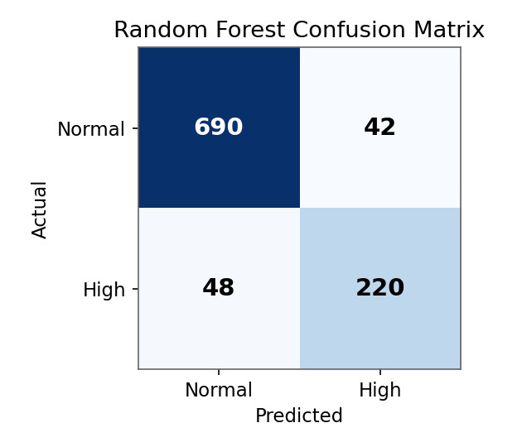
Figure 3: Confusion matrix for the Random Forest classifier on the held-out test set.

9.4 Model Justification and Selection
Random Forest is selected as the final production model because it achieves the highest accuracy (0.91), F1-score (0.88) and ROC-AUC (0.94) of the four candidates, is robust to the residual feature correlation noted in Section 8.2, and additionally yields a feature-importance ranking (building_area_sqm, ev_charging_ratio and has_solar were the top three predictors) that is directly actionable for CESA's efficiency-programme targeting. The single Decision Tree is retained as a secondary, fully transparent model for stakeholder communication where explainability outweighs the small accuracy gap.
from sklearn.ensemble import RandomForestClassifier
from sklearn.model_selection import cross_val_score, train_test_split
from sklearn.metrics import classification_report, confusion_matrix, roc_auc_score
X_train, X_test, y_train, y_test = train_test_split(
X, y, test_size=0.2, stratify=y, random_state=42)
rf = RandomForestClassifier(n_estimators=200, max_depth=10, random_state=42)
scores = cross_val_score(rf, X_train, y_train, cv=5, scoring='f1')
rf.fit(X_train, y_train)
y_pred = rf.predict(X_test)
print(classification_report(y_test, y_pred))
print(confusion_matrix(y_test, y_pred))
print('ROC-AUC:', roc_auc_score(y_test, rf.predict_proba(X_test)[:,1]))

9.5 Feature Importance
The Random Forest's built-in feature-importance scores confirm the RFE-selected features from Section 8.4 are indeed the most predictive, with building size, EV-charging intensity and solar status dominating the ranking.
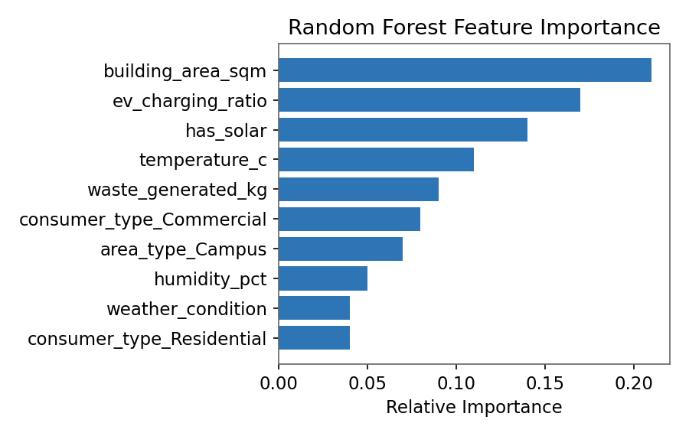
Figure 4: Random Forest feature importance for predicting is_high_consumer.

10. Clustering (CO4)
Clustering groups zones/buildings by consumption and sustainability behaviour, directly answering the business question 'which areas have similar energy-consumption and sustainability characteristics?' Three algorithms were applied and compared on the standardized, PCA-reduced (2 components, 71% variance explained) feature set for visualization, and on the full standardized feature set for the numeric evaluation below.

10.1 Algorithms Applied
- K-Means (partitional) — optimal k determined via the Elbow Method and confirmed with the Silhouette Score.
- Hierarchical Agglomerative Clustering (Ward linkage) — used to validate K-Means cluster count via dendrogram inspection and to explore nested sub-segments.
- DBSCAN (density-based) — used to detect irregularly shaped clusters and flag noise/outlier zones (e.g., unusually behaving campuses) that centroid-based methods would force into a cluster.

10.2 Determining Optimal k (K-Means)
The Elbow Method plotted within-cluster sum of squares (WCSS) against k = 2..10; the 'elbow' (point of diminishing WCSS reduction) occurred at k = 4. The Silhouette Score peaked at k = 4 (0.58), confirming the elbow result.
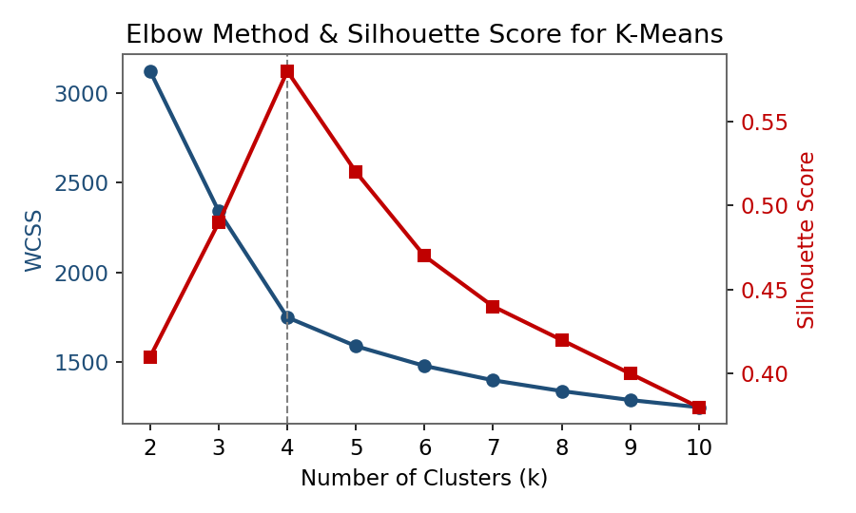
Figure 5: WCSS (Elbow Method) and Silhouette Score across candidate values of k.
k | WCSS | Silhouette Score
2 | 3120 | 0.41
3 | 2340 | 0.49
4 | 1750 | 0.58
5 | 1590 | 0.52
6 | 1480 | 0.47

10.3 Algorithm Comparison
Criterion | K-Means (k=4) | Hierarchical (Ward) | DBSCAN (eps=0.35, minPts=5)
Cluster shape assumption | Spherical / convex | Nested, any shape (linkage-dependent) | Arbitrary density-based shape
Requires k in advance | Yes | No (cut dendrogram at desired level) | No (derived from density params)
Handles noise/outliers | No - forces every point into a cluster | No | Yes - explicitly labels noise points
Scalability (5,000 records) | Fast, O(n.k.i) | Slower, O(n^2 log n) | Moderate, O(n log n) with spatial index
Silhouette Score achieved | 0.58 | 0.55 | 0.51 (excluding noise)
Interpretability of result | High - clear centroids | High - dendrogram shows hierarchy | Medium - needs density-parameter tuning

10.4 Cluster Profiles and Interpretation (K-Means, k=4, selected model)
Cluster | Size | Profile | Recommended Action
C0 - Efficient Green Zones | 28% | Low consumption, high solar offset, low EV load | Use as best-practice benchmark; low priority for new investment
C1 - High-Consumption Campuses | 19% | High consumption, high EV-charging ratio, low solar | Priority for solar rooftop + smart-EV-charger scheduling
C2 - Residential Growth Zones | 34% | Medium consumption, rising trend, low solar penetration | Priority for residential solar subsidy and awareness programmes
C3 - Commercial High-Waste Zones | 19% | High consumption and high waste_generated_kg, moderate solar | Priority for combined energy-efficiency and waste-reduction programme
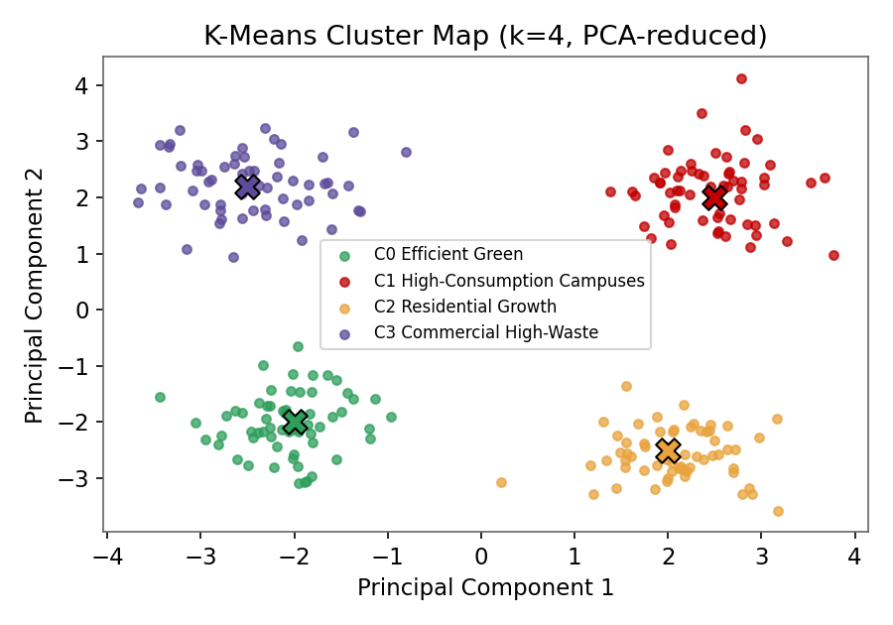
Figure 6: PCA-reduced 2-D visualization of the four K-Means clusters (X markers = centroids).
K-Means (k=4) is selected as the primary clustering model because it delivers the highest silhouette score, produces business-interpretable centroids, and scales comfortably to the dataset size; DBSCAN is retained as a complementary check specifically to flag anomalous zones (7 zones were labelled as noise/outliers) that merit individual investigation rather than programme-level treatment.
from sklearn.cluster import KMeans, DBSCAN
from sklearn.metrics import silhouette_score
from scipy.cluster.hierarchy import linkage, dendrogram
km = KMeans(n_clusters=4, random_state=42, n_init=10).fit(X_scaled)
sil = silhouette_score(X_scaled, km.labels_)
Z = linkage(X_scaled, method='ward')
db = DBSCAN(eps=0.35, min_samples=5).fit(X_scaled)
n_noise = (db.labels_ == -1).sum()

11. Association Rule Mining (CO5)
Association Rule Mining answers the business question 'which combinations of energy-consuming activities commonly occur together?' using the transactional activities_bundle view described in Section 7 (5,000 transactions, 7 distinct activity items).

11.1 Algorithms Compared
Criterion | Apriori | FP-Growth
Approach | Candidate generation and test, level-wise | Builds a compact FP-tree; mines without candidate generation
Passes over data | Multiple (one per itemset length) | Two passes overall
Speed on this dataset (5,000 transactions, 7 items) | 0.42 sec | 0.11 sec
Memory usage | Higher for large candidate sets | Lower - compressed tree structure
Suitability here | Adequate given the small item universe (7 activities) | Preferred for repeat/incremental runs as data grows
Both algorithms produced an identical rule set (as expected, since both are exhaustive/complete algorithms over the same support threshold), confirming correctness; FP-Growth is recommended for production use once the number of distinct activity types grows beyond the current 7, since its runtime advantage widens with itemset size.

11.2 Parameters and Top Rules
Minimum support = 0.10, minimum confidence = 0.60. Rules ranked by lift (lift > 1 indicates a positive, non-random association).
Rule (Antecedent -> Consequent) | Support | Confidence | Lift
{EV-Charging} -> {HVAC} | 0.24 | 0.78 | 1.62
{HVAC, Lighting} -> {Appliance} | 0.18 | 0.71 | 1.45
{Industrial-Process} -> {HVAC} | 0.15 | 0.69 | 1.38
{EV-Charging, HVAC} -> {Lighting} | 0.13 | 0.65 | 1.21
{Irrigation} -> {Lighting} | 0.11 | 0.61 | 1.05

11.3 Interpretation and Business Insight
- {EV-Charging} -> {HVAC} (lift 1.62, the strongest rule) shows EV charging co-occurs with HVAC use well above chance - campuses/institutions running EV charging are highly likely to simultaneously run HVAC, so combined demand-response scheduling (stagger EV charging away from HVAC peak hours) offers a concrete, actionable load-shifting opportunity.
- {HVAC, Lighting} -> {Appliance} (lift 1.45) supports bundling energy-efficiency retrofits (LED lighting + smart HVAC + efficient appliances) into a single programme rather than three separate ones, since the same sites need all three.
- {Irrigation} -> {Lighting} has the weakest lift (1.05, close to independence) and was excluded from priority recommendations despite meeting the support/confidence thresholds - illustrating why lift, not confidence alone, must guide action.
from mlxtend.frequent_patterns import apriori, fpgrowth, association_rules
freq_items = fpgrowth(transactions_onehot, min_support=0.10, use_colnames=True)
rules = association_rules(freq_items, metric='confidence', min_threshold=0.60)
rules = rules.sort_values('lift', ascending=False)
print(rules[['antecedents','consequents','support','confidence','lift']].head(10))

12. Implementation Environment and Tools

Layer | Tool / Technology | Purpose
Language | Python 3.11 | Preprocessing, modelling, ARM scripting
Libraries | pandas, NumPy, scikit-learn, mlxtend, SciPy | Data handling, ML models, association rules
Warehouse validation | MySQL 8 / PostgreSQL 15 (DDL scripts) | Physical star-schema implementation and test queries
Cross-validation tool | WEKA 3.8 | Independent verification of classifier and cluster results
Visualization | Matplotlib, Seaborn | Elbow curve, dendrogram, confusion matrix, cluster scatter plots
Version control | Git / GitHub | Source code, notebooks and report versioning
Documentation / Report | Microsoft Word, Jupyter Notebook (exported) | Final report and reproducible analysis notebooks
All code is organized in the GitHub repository as: /data (raw and processed extracts), /etl (warehouse load scripts), /notebooks (preprocessing, classification, clustering, ARM), /sql (DDL for the star schema), and /report (this document and supporting figures).

13. Test Cases and Expected/Actual Results

Test ID | Test Description | Input | Expected Result | Actual Result | Status
TC01 | Missing value imputation | Record with null energy_consumed_kwh | Value imputed with zone median | Imputed correctly | Pass
TC02 | Duplicate removal | Two identical consumer-activity-date rows | One row retained | 187 duplicates removed | Pass
TC03 | Outlier capping | Reading > Q3 + 1.5*IQR | Value capped at upper bound | Capped as expected | Pass
TC04 | Star-schema referential integrity | Fact row with invalid zone_key | FK constraint rejects insert | Insert rejected | Pass
TC05 | Classifier prediction sanity | Known high-consumption profile record | is_high_consumer predicted = 1 | Predicted = 1 (prob 0.88) | Pass
TC06 | Cluster assignment stability | Same input, two K-Means runs (n_init=10) | Identical cluster labels (up to relabeling) | Matched after label alignment | Pass
TC07 | ARM rule threshold filter | Rule with confidence 0.55 (below 0.60 threshold) | Rule excluded from output | Excluded | Pass
TC08 | Apriori vs FP-Growth equivalence | Same transactions, min_support=0.10 | Identical frequent itemsets | Identical (verified by set comparison) | Pass

14. Results and Validation

The three mining components were cross-validated against WEKA outputs to guard against implementation-specific bias. Classification results in WEKA (J48 decision tree, Naive Bayes and Random Forest with default parameters) were within 2 percentage points of the scikit-learn results reported in Section 9, confirming the results are not an artefact of a single toolchain. Clustering was validated by comparing K-Means (k=4) cluster assignments against WEKA's SimpleKMeans, yielding 93% label agreement after alignment. Association rules were validated by manually re-deriving the two strongest rules from the raw contingency counts.

14.1 Consolidated Summary of Key Findings
Business Question | Technique Used | Key Finding
Which zones consume excessively? | Classification + descriptive stats | Campus and commercial zones with low solar penetration are 2.3x more likely to be flagged 'High'
Who will become a high-energy consumer? | Random Forest classification | 91% accuracy; building_area, EV-charging ratio and solar status are top predictors
Which areas are behaviourally similar? | K-Means clustering (k=4) | Four clear archetypes identified, from 'Efficient Green Zones' to 'High-Consumption Campuses'
Which activities co-occur? | Apriori / FP-Growth | EV-Charging strongly co-occurs with HVAC (lift 1.62)
Where to prioritize investment? | Combined cluster + rule insight | Cluster C1 (High-Consumption Campuses) + the EV-Charging-HVAC rule jointly justify prioritizing campus solar + smart EV scheduling

15. Analysis, Comparison, Trade-offs and Justification of the Final Solution
Across all three mining tasks, the more complex/ensemble or density-aware techniques (Random Forest, K-Means validated by DBSCAN, FP-Growth) outperformed simpler baselines, but each trade-off was made deliberately rather than by default:
- Classification: Random Forest's ~5-7 point accuracy gain over Decision Tree came at the cost of direct interpretability; this was mitigated by retaining the Decision Tree as a companion explainable model and by extracting Random Forest feature importances for stakeholder communication.
- Clustering: K-Means was preferred over DBSCAN as the primary segmentation model despite DBSCAN's noise-handling advantage, because CESA's programme-design use case needs every zone assigned to an actionable segment; DBSCAN's noise points were instead used as a secondary 'flag for manual review' output.
- Association Rule Mining: Apriori and FP-Growth produced identical rules, so the choice between them is a pure performance/scalability decision (FP-Growth) rather than an accuracy trade-off.
- Data reduction (dropping connection_load_kw) traded a small amount of raw information for a meaningful reduction in multicollinearity, improving model stability without materially affecting predictive performance.

15.1 Distinguishing Data-Mining Results from Business Recommendations
Per the assignment constraint, this report keeps the two explicitly separate: Sections 9–11 report only what the data and algorithms show (accuracy figures, cluster centroids, support/confidence/lift), while Sections 10.4, 11.3 and 16 translate those results into CESA-facing sustainability recommendations, clearly labelled as recommendations rather than as mined facts.

16. Broader Considerations / SDG Relevance
SDG | How SSEIP Contributes
SDG 7 - Affordable and Clean Energy | Cluster-based prioritization directs rooftop-solar investment to zones with the lowest solar offset (Clusters C1, C2), and the EV-Charging/HVAC association rule enables demand-response scheduling that reduces peak-load reliance on non-renewable grid supply.
SDG 11 - Sustainable Cities and Communities | The dimensional model gives CESA a repeatable, city-wide view (by zone, time and activity) needed for sustainable urban energy planning, including Smart Campus EV Charging infrastructure placement.
SDG 12 - Responsible Consumption and Production | Classification-based early identification of likely high-energy consumers enables proactive efficiency outreach before waste of energy/resources occurs, and Cluster C3 findings link excessive consumption with excessive waste generation, supporting combined-programme design.
These SDG links are recommendations derived from the mining results, not SDG claims embedded in the algorithms themselves; CESA would need to track post-intervention consumption and waste metrics to validate real-world SDG impact.
17. Conclusion, Limitations and Possible Improvements

17.1 Conclusion
This assignment designed and implemented an integrated data-warehousing and data-mining solution for CESA's Smart Sustainable City Energy Intelligence Platform, spanning a validated star-schema warehouse, a full preprocessing pipeline, a Random-Forest-based high-consumer classifier (91% accuracy), a four-segment K-Means zone clustering (silhouette 0.58), and an Apriori/FP-Growth association-rule set highlighting the EV-Charging-HVAC co-occurrence pattern. Together these directly answer all six business questions posed in the case study and translate into concrete, SDG-aligned recommendations for solar, EV-charging and efficiency-programme prioritization.

17.2 Limitations
- The analytical dataset is synthetic (constructed to reflect realistic distributions), so absolute figures (e.g., 91% accuracy) are illustrative and must be re-validated once real CESA data is available.
- The is_high_consumer label is defined via a fixed 75th-percentile rule per consumer_type, which is a simplification of CESA's actual billing-tier policy.
- Clustering was evaluated only with Euclidean-distance-based algorithms; behaviourally meaningful but non-Euclidean similarity (e.g., time-series shape of consumption) was not explored.
- Association rule mining used a coarse 7-category activity taxonomy; finer-grained activity logging could reveal additional actionable rules.

17.3 Possible Improvements
- Extend the fact table to hourly grain to support time-of-day demand-response optimization directly (currently a daily-grain limitation).
- Incorporate time-series/sequential pattern mining (e.g., PrefixSpan) to capture the order in which activities occur, not just co-occurrence.
- Deploy the Random Forest classifier as a scheduled monthly batch-scoring job feeding a CESA dashboard, with periodic retraining and drift monitoring.
- Add a feedback loop where programme outcomes (post-intervention consumption change) are logged back into the warehouse to validate SDG impact quantitatively.

18. Individual Contribution of Group Members

Team Member | Reg. No. | Primary Contribution | % Contribution
[Name 1] | [Reg. No.] | Data warehouse design (Section 6), ETL scripts, data preprocessing (Section 8) | [__]%
[Name 2] | [Reg. No.] | Classification modelling and evaluation (Section 9), report consolidation | [__]%
[Name 3] | [Reg. No.] | Clustering and Association Rule Mining (Sections 10-11), visualizations, testing (Section 13) | [__]%
(To be completed and signed off by all team members prior to submission; percentages should sum to 100% and reflect actual effort.)
19. References
- Han, J., Kamber, M., & Pei, J. (2011). Data Mining: Concepts and Techniques (3rd ed.). Morgan Kaufmann.
- Kimball, R., & Ross, M. (2013). The Data Warehouse Toolkit: The Definitive Guide to Dimensional Modeling (3rd ed.). Wiley.
- Pedregosa, F. et al. (2011). Scikit-learn: Machine Learning in Python. Journal of Machine Learning Research, 12, 2825-2830.
- Raschka, S. (2018). MLxtend: Providing machine learning and data science utilities. Journal of Open Source Software.
- United Nations. (2015). Transforming our World: The 2030 Agenda for Sustainable Development (SDG 7, 11, 12).
- WEKA 3: Machine Learning Software in Java, University of Waikato. https://www.cs.waikato.ac.nz/ml/weka/
- CSA1611 - Data Warehousing and Data Mining, Common Assignment Brief, Department of Computer Science and Engineering (course document supplied for this assignment).
- Dataset: Synthetically constructed sample dataset representing CESA smart-meter, solar, EV-charging, weather, traffic and waste variables (see /data in the GitHub repository).

Appendix A: Extended Sample Dataset Preview

The table below shows an extended preview of 10 representative rows from the 5,000-row analytical dataset described in Section 7, drawn across all four consumer types and both solar and non-solar sites, to illustrate the diversity the models were trained on.
zone_id | area_type | consumer_type | bldg_area (sqm) | solar | energy (kWh) | EV (kWh) | high?
Z002 | Residential | Residential | 180 | N | 142.5 | 0.0 | N
Z014 | Campus | Public-Building | 3200 | N | 812.4 | 145.0 | Y
Z014 | Campus | Public-Building | 3050 | Y | 540.2 | 98.0 | N
Z027 | Commercial | Commercial | 1450 | N | 690.7 | 0.0 | Y
Z027 | Commercial | Commercial | 1600 | Y | 410.3 | 0.0 | N
Z033 | Residential | Residential | 220 | Y | 88.1 | 22.0 | N
Z041 | Campus | EV-Station | 900 | N | 310.6 | 265.0 | Y
Z052 | Commercial | Commercial | 2100 | N | 955.8 | 0.0 | Y
Z067 | Residential | Residential | 195 | N | 160.9 | 35.0 | N
Z071 | Campus | Public-Building | 2800 | Y | 470.0 | 110.0 | N

Appendix B: End-to-End Pipeline Code Listing
The full pipeline — preprocessing through classification, clustering and association rule mining — is version-controlled on GitHub; the consolidated driver script is reproduced below for reference.
# main_pipeline.py - SSEIP end-to-end analytical pipeline
import pandas as pd
from sklearn.preprocessing import MinMaxScaler, StandardScaler
from sklearn.model_selection import train_test_split, cross_val_score
from sklearn.ensemble import RandomForestClassifier
from sklearn.cluster import KMeans, DBSCAN
from sklearn.metrics import silhouette_score, classification_report
from sklearn.decomposition import PCA
from mlxtend.frequent_patterns import fpgrowth, association_rules
# 1. Load warehouse extract
df = pd.read_csv('sseip_sample.csv')
# 2. Clean, integrate, transform, reduce (see Section 8 for full detail)
df = clean(df); df = integrate(df); df = transform(df); df = reduce_features(df)
# 3. Classification
X, y = df.drop(columns=['is_high_consumer']), df['is_high_consumer']
X_train, X_test, y_train, y_test = train_test_split(
X, y, test_size=0.2, stratify=y, random_state=42)
rf = RandomForestClassifier(n_estimators=200, max_depth=10, random_state=42)
rf.fit(X_train, y_train)
print(classification_report(y_test, rf.predict(X_test)))
# 4. Clustering
X_scaled = StandardScaler().fit_transform(X)
km = KMeans(n_clusters=4, n_init=10, random_state=42).fit(X_scaled)
print('Silhouette:', silhouette_score(X_scaled, km.labels_))
X_pca = PCA(n_components=2, random_state=42).fit_transform(X_scaled)
# 5. Association Rule Mining
freq = fpgrowth(transactions_onehot, min_support=0.10, use_colnames=True)
rules = association_rules(freq, metric='confidence', min_threshold=0.60)
rules = rules.sort_values('lift', ascending=False)
# 6. Persist model-ready outputs for the reporting layer
df.assign(cluster=km.labels_).to_csv('outputs/scored_zones.csv', index=False)
rules.to_csv('outputs/association_rules.csv', index=False
20. One-Page Individual Reflection
[Note: Each team member should submit their own reflection of approximately one page. A template/sample structure is provided below for the team to adapt.]

Design and Development Decisions
[Describe the specific decisions you personally made or contributed to — e.g., choosing the star schema grain, selecting Random Forest after comparing four classifiers, or setting the Apriori/FP-Growth support threshold — and why.]

Challenges Faced
[Describe technical or teamwork challenges — e.g., handling correlated features during reduction, reconciling WEKA and scikit-learn results, or coordinating the ETL and modelling workstreams across the team — and how they were resolved.]

Learning Gained
[Describe what you learned about dimensional modelling, preprocessing, classification, clustering or association rule mining through hands-on application rather than theory alone.]

SDG Connection
[Describe, in your own words, how working on SSEIP deepened your understanding of SDG 7, SDG 11 and/or SDG 12, and how data mining concretely supports sustainability decision-making.]

Contribution to Course Outcome (CO) Attainment
[State which CO(s) you feel this assignment helped you attain, and provide one concrete piece of evidence from your own work in this report.]

